SCREENSHOTS FOR DJANGO ASSIGNMENT:

1) after navigating to the url : localhost:8000/member/users

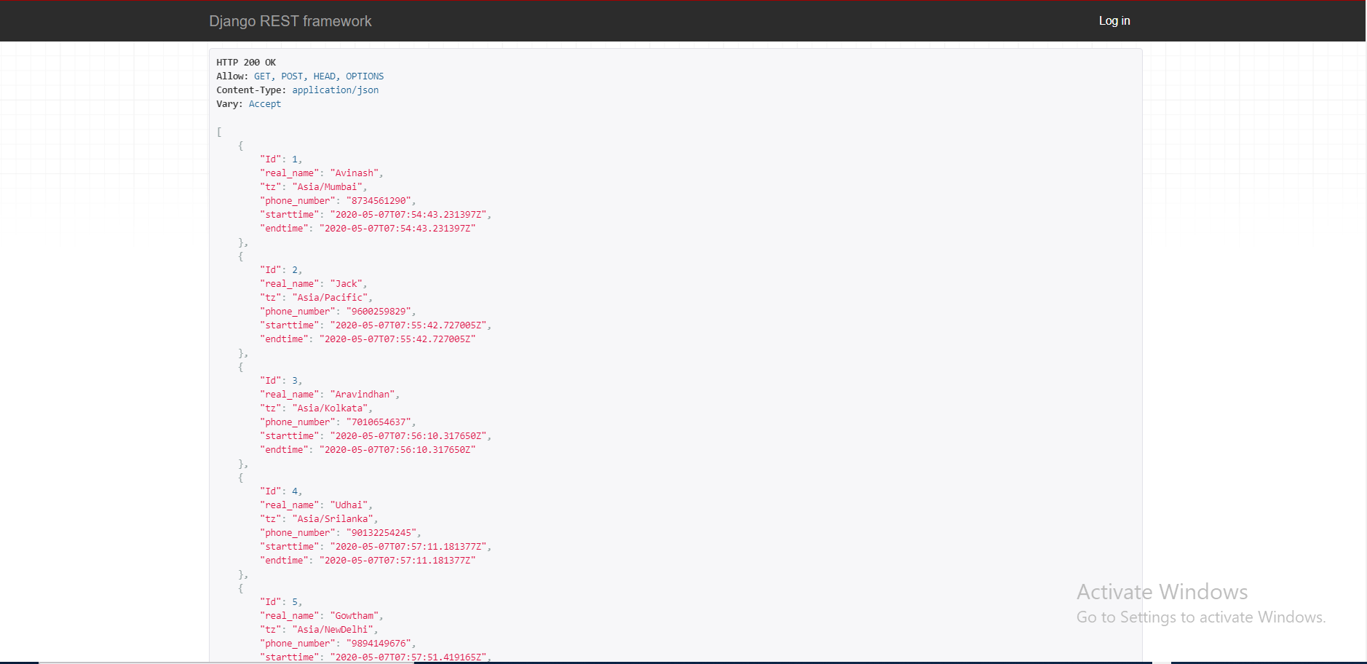

2) we can add our data through POST request

